TEST AUTOMATION · EXERCISE 01
Playwright MCP Checkout Rescue
Implementation evidence and a concise review of its value for junior and senior engineers
Project: checkout-e2e-app
Branch: fix/playwright-checkout-rescue
Assessment date: 30 July 2026
Time-box: Designed for 30 minutes; source repair required additional work
Verdict. Strong junior-level learning objectives, but the current upstream project is not a valid 30-minute checkout-rescue exercise. After the source mismatch is repaired, it is useful for juniors and too shallow for seniors unless an advanced extension is added.

1. What the exercise actually shipped
The brief promises brittle checkout coverage around cart, tax quote, payment authorization, and Playwright traces. The repository instead rendered a static lab-contract dashboard. Its starter test slept for 500 ms, searched for a CSS class on an unmounted work-queue component, and timed out after 30 seconds. This was a deterministic product/test mismatch, not an intermittent checkout failure.
Root cause: The exercise contract, production UI, and starter test were generated from different application concepts. Repository history showed the mismatch was introduced with the current exercise rather than by a later learner change.
Consequence: A learner following only the selector-replacement instruction cannot complete the mission; no checkout path or payment boundary exists to inspect.

2. Rescue implemented
Real browser flow: A minimal cart, postal-code tax quote, card authorization, approved confirmation, and declined-payment recovery now run in React.
Resilient coverage: Tests use roles, labels, visible outcomes, and Playwright web-first assertions. Fixed waits, CSS selectors, DOM indexes, and retry-based masking were removed.
Boundary isolation: A custom per-test fixture intercepts only tax and payment requests, records literal payloads, and configures approved or declined authorization without suite-level shared state.
Evidence: Playwright produces a console and HTML report plus a trace, screenshot, and video for every evidence-run test.

3. Verification evidence
Gate | Observed command or evidence | Outcome
Seeded baseline | npm run test:e2e -- --reporter=line | Failed: .queue-item timed out
Focused flow | npx playwright test --reporter=line | 2 passed
Parallel repeat | npx playwright test --repeat-each=10 --workers=2 | 20 passed in 40.2 s
Repository gate | npm run agent:check | Lint, checks, format, typecheck, build passed
Locator audit | Search for waits, CSS locators, nth/first | 0 matches
Browser artifacts | test-results and HTML report | 20 traces, 20 screenshots, 20 videos
Browser evidence: successful payment confirmation from the repeated parallel run.
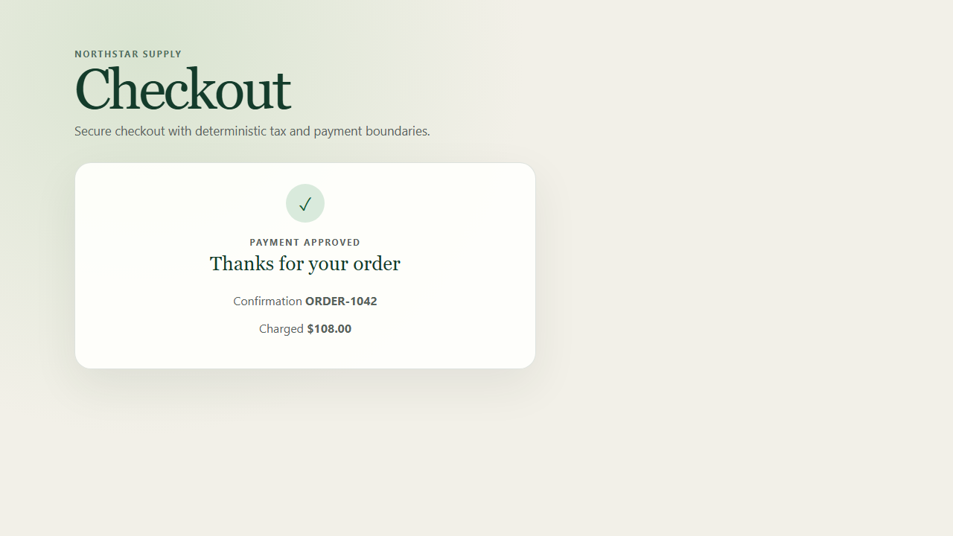

4. Audience fit
Junior engineers — helpful after repair: The exercise teaches high-value habits in a compact domain: observe before editing, prefer accessible locators, wait on user-visible state, isolate external boundaries, and prove stability with repetition. The red-green comparison is especially concrete.
Junior risk: In its current upstream form, learners may conclude that they are expected to invent the application. That tests product reconstruction and ambiguity tolerance more than Playwright reliability.
Senior engineers — insufficient as written: Once the source is coherent, the solution is routine. Senior value would require diagnosing a true race, inspecting trace timing, handling parallel data collisions, or choosing the correct mock boundary under realistic constraints.

5. How to improve the exercise
- Repair the starter repository. Ship a functioning checkout whose seeded failures match the brief: a real fixed sleep after authorization, one generated-class selector, and a payment mock with demonstrable cross-test leakage.
- Make the failure reproducible. Provide a command such as --repeat-each=20 --workers=2 that fails often enough to investigate, while keeping the underlying application deterministic.
- Define the evidence contract. Specify whether learners must submit a trace.zip, HTML report, screenshot, console transcript, or all four; include paths and a maximum artifact size.
- Add a scoring rubric. Score role/label locators, absence of fixed waits, mock isolation, request-payload assertions, repeated parallel success, and explanation of the root cause.
- Split junior and senior tracks. Keep the repaired two-path rescue for juniors. Add a senior extension with worker-index collisions, a delayed tax response, trace-based diagnosis, CI sharding, and a mutation that proves the test catches a regression.
- Clarify PR mechanics. State whether participants should fork the public repository, which base branch to target, and whether generated evidence belongs in Git or in the PR description.

6. Final assessment
Learning value: Good for juniors after source repair; limited for seniors without an advanced extension.
Current exercise quality: Not ready for unsupervised use because the shipped application does not contain the workflow being tested.
Recommended disposition: Adopt the repaired starter, retain the 30-minute junior challenge, and publish a separate senior track with trace-led diagnosis and parallel-state complexity.

